

C1: Introduction to SE

- Quality focus
  - Any engineering approach must rest on an organizational commitment to quality.
  - The comprehensive quality management can lead to a more advanced development and more mature software engineering.

- Process
  - It defines a framework for sequence and flow of software engineering activities to ensure an effective delivery of software engineering technology.

- Methods
  - It is an organized way of producing software.
  - It includes the suggestion for the process to be followed, notations, rules governing the system description and design guidelines.

- Tools
  - It provides automated and semi-automated support to the process and methods.

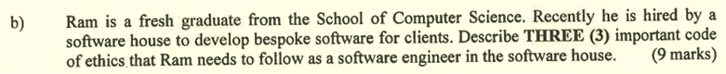

C1: Introduction to SE (rare)

- Public
  - Software engineers shall act consistently with the public interest.

- Client and employer
  - Software engineers shall act in a manner that is in the best interests of their client and employer consistent with the public interest.

- Product
  - Software engineers shall ensure that their products and related modifications meet the highest professional standards possible.

- Judgment
  - Software engineers shall maintain integrity and independence in their professional judgment.



C1: Introduction to SE (Key Challenges of Software Engineering)

- Legacy Challenge
  - It may lead to excessive cost when maintaining and updating the legacy software.
  - Meanwhile, software engineers also have to ensure that the essential business services can be continuously delivered.

- Heterogeneity / Diversity Challenge
  - The software engineers need to build a dependable software which can adapt to different types of computer and support systems.

- Delivery Challenge
  - The software engineers have to shorten the delivery time for large and complex systems without affecting the software quality.
  - It is difficult to promise a consistent and short delivery time when the client frequently changes the system requirements during the development period.

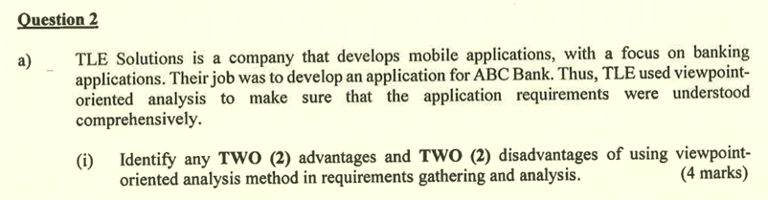

C5: Requirements Engineering Process (answers not in lecture notes)

Advantages
- Multiple perspectives
  - This method can capture the needs and requirements from various stakeholders or user groups to ensure a comprehensive coverage.

- Improve communications
  - It can facilitate the communication between developers and stakeholders by focusing on specific viewpoints.

- Conflict resolution
  - It can identify and resolve the conflicting requirements early by addressing different perspectives.

- Enhance traceability
  - It allows better traceability of requirements to specific stakeholders which can improve the accountability and validation during development.

- Structured approach
  - It provides a systematic way to organize and categorize the requirements based on different perspectives. Thus, the analysis will be more manageable.

Disadvantages
- Time-consuming
  - It will spend more time gathering and analyzing the requirements from different viewpoints.

- Complexity
  - More conflicting requirements might happen when managing a large number of viewpoints.
  - This will increase the complexity of the process.

- Stakeholder engagement
  - This method requires active involvement from all stakeholders.
  - It might not be feasible if there is no active involvement, it would lead to incomplete or biased viewpoints.

- Integration difficulty
  - It may be difficult or challenging to combine and harmonize different viewpoints into a cohesive system.

C5: Requirements Engineering Process

Interactor viewpoints
- Online Client
- Bank Teller

Indirect viewpoints
- Human Resource Manager
- Manager
- Chief Executive Officer

Domain viewpoints
- User Interface Standards
- Company Policy

(Draw viewpoint hierarchy)

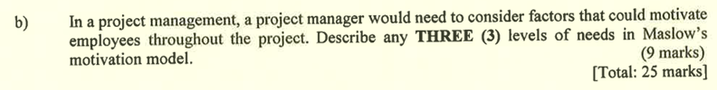

C3: Project Management (Maslow’s Motivation Model)

- Self-actualization
  - This level of needs can enable employees to achieve their full potentials or even improve their existing skills.
  - It also provides opportunities to employees to explore for their professional growth.

- Esteem needs
  - This level of needs focus on enabling employees to gain self-esteem, achievement, respect from others and recognition.
  - The company should recognize employees’ achievement publicly, provide constructive feedback to employees and also celebrate employees’ success for helping them to gain more confidence and respect.

- Belongingness and love needs
  - This level of needs focus on establishing healthy relationships between friends, families and even company team members.
  - The company should build a collaborative environment which enables employees to communicate with each other to establish a good relationship and strong collaboration.
  - The company should also conduct team bonding events regularly for enabling employees to build strong team relationships and collaboration bonding.

- Safety needs
  - This level of needs prioritizes the security and safety of employees.
  - The company should always provide a safe working environment, stable project and excellent job security for its employees.

- Physiological needs
  - This level of needs prioritizes the fundamental needs for employees to survive.
  - For example, the provision of food, water and shelter.
  - The company can achieve this via offering sufficient lunch breaks for employees to take lunch and energize themselves via rest.

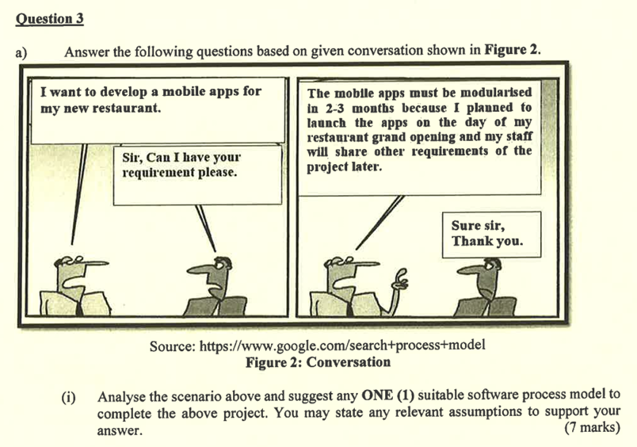

From the conversation,
Keypoints:
- Modularised in 2-3 months

- Launch apps on the day of restaurant grand opening

- Share other requirements later

- Well-known goals although requirements are not stated

Answer:
- Rapid Application Development (RAD) Model

- Since the mobile apps must be modularised in 2-3 months and launched on the day of restaurant grand opening, this model is able to create the project that modularizes in a short span of time which is between 2 to 3 months.

- Since the well-known goal of the mobile app for restaurant purposes is stated, this model is suitable as it can create the prototype quickly and complete the system via iterative development.

- Since the other requirements of the project will be shared later, this model is suitable because it can easily adapt to incoming changes on requirements.

- Requirements Planning
  - A clear requirement or goals will be determined before start to build the prototype.

- Prototype
  - Software engineer will build a prototype based on the existing requirements and goals provided.

- Test
  - The prototype will be tested to ensure no errors or bugs inside the prototype.

- Refine
  - Software engineer will refine the prototype based on requirement changes requested by the client.
  - The process of prototype, test, refine will be iterated repeatedly until the final prototype is satisfied by the client.

- Construction
  - The software developers will write the codes to convert the final prototype into a real and full functional software.

- Cutover
  - Cutover is the process of transition from the old system to the new system.
  - It will deploy the new developed software into the real production environment.

- Customer satisfaction by rapid delivery of useful software.
- Welcome changing requirements, even late in development.
- Working software is delivered frequently (in weeks).
- Sustainable development, able to maintain a constant pace.
- Face-to-face conversation is the best form of communication.
- Self-organizing teams.
- Regular adaptation to changing circumstances.

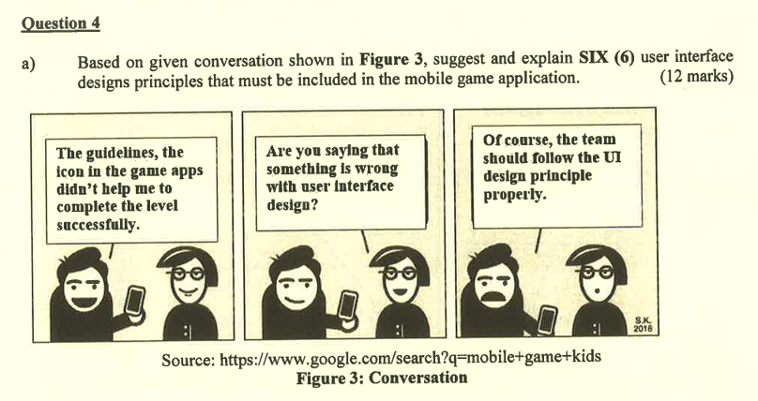

C8: User Interface Design (UI Design Principle)

- Consistency
  - It refers to the operations should be activated in the same way if possible.
  - The game apps should apply a standardized design layout and behavior on every possible pages. So, the users only have to learn and recognize one way to execute the action once. Then, they can apply the same strategy to another pages. This can effectively reduce the learning time and cost for the users, especially for the novice users.
  - For example, the position of the back button is always located at the top left corner of the game apps pages.

- User Familiarity
  - It refers to the game apps should use the terms and concepts which are drawn from user experience.
  - The game apps should refer to the layout design of other popular game application, then design the game apps using the similar or advanced layout design instead of using a totally different layout design.
  - So, it can draw a sense of familiarity of using the system to the users. They can easily and quickly learn to use the system.

- User Guidance
  - It refers to providing help features and meaningful feedback when errors occur.
  - The game apps should offer a function “quick access to game tutorial or guidance” for every user. So, users can manually access it to view the game tutorials video or step-by-step interactive tutorial.
  - The game apps can also automatically display the game tutorials if the users are playing the game for the first time. When the users have done something wrong, the game apps will remind the users using appropriate and meaningful messages. Thus, the users can quickly and easily master the way of playing the game.

- User Diversity
  - It refers to providing appropriate interaction facilities to different types of system users.
  - Since users from different countries may have different preferred languages, the game apps should provide an option for all users to select and apply their preferred languages. So, they can easily understand the content in the game apps without manually translating them into recognizable languages.

- Minimal Surprise
  - It refers to users should not be surprised by the behavior of the system.
  - In game apps, it should provide the sufficient dialog for users once the users have executed any action. So, the users will get to know what is going on or what is the current state of the game apps.
  - For example, the game apps should display a dialog which tells the users the player matching is under progress after users clicked on start game and the game apps start finding the players for matching. Instead of staying in the same page without notifying the users anything, the game apps should navigate user to waiting player page or pop out waiting player dialog on the current page. Thus, the users will be acknowledged that the game apps are finding the matching players for him.

- Recoverability
  - It refers to allowing users to recover from errors.
  - In game apps, it should allow the users to rename their own player name. If the users have accidentally entered a wrong name, the game apps will still give them 3 free chances for changing their player name. Thus, the users can still re-enter the correct name and recover the human errors just now.

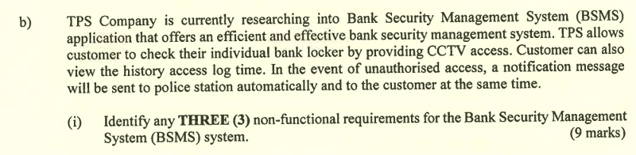

C4: System Requirements (Non-functional requirements)

1.0 Usability
1.1 The system shall have low learning time via applying consistent layout design for every possible page with familiar icons.

2.0 Delivery
2.1 The system should be developed and delivered within 3 months.

3.0 Safety
3.1 The system shall not disclose any private information of the system user based on security standard DCI PSS.



C4: System Requirements (Problems with Natural Language)

- Lack of clarity
  - It is difficult to use language in a precise and unambiguous way without making the document wordy and hard to read.

- Requirements confusion
  - The functional requirements, non-functional requirements, system goals and design info may not be clearly distinguished.
  - Different requirements may be expressed by different parties or perspectives.

- Requirements amalgamation
  - Several requirements might be expressed as a single requirement.

